**1 (*) Terminologies**

**State** : A State can be defined as a possible valid configuration in an event , for example if we consider the game of snake and ladder a state can be defined as a particular number between 1 to 100 which states where your current position is.

**State Space** : A State space can be defined as a set of all valid states or a set of all possible valid configuration. For example in the game of snake and ladder the state space is a number in the range 1 to 100 , which can be denotes as S belongs to [1,100].

**Successor Function** : A Successor Function is the one which decides the next state after one step. It helps in identifying how the next state will look like after one step . For example in the game of snake and ladder the successor function will decide what is the next achievable position based on the value appeared on the dice and we encounter the snake or ladder .

**Initial State Set** : A Initial State Set is the starting state or the first available state in the event . For the initial state set we apply the successor function to go through different states and reach the Final State or Goal State. For example in the game of snake and ladder the initial state set is the position 1.

**Goal State Set** : It is the Final state or the last state in the event .After achieving this state we stop the process.

**2 (**) Rubics Cube**

There are 3,674,160 possible valid states in a 2x2x2 rubics cube which makes up the state space . The state space is a set S consisting of all these 3,674,160 possible valid states . A State in rubics cube looks like

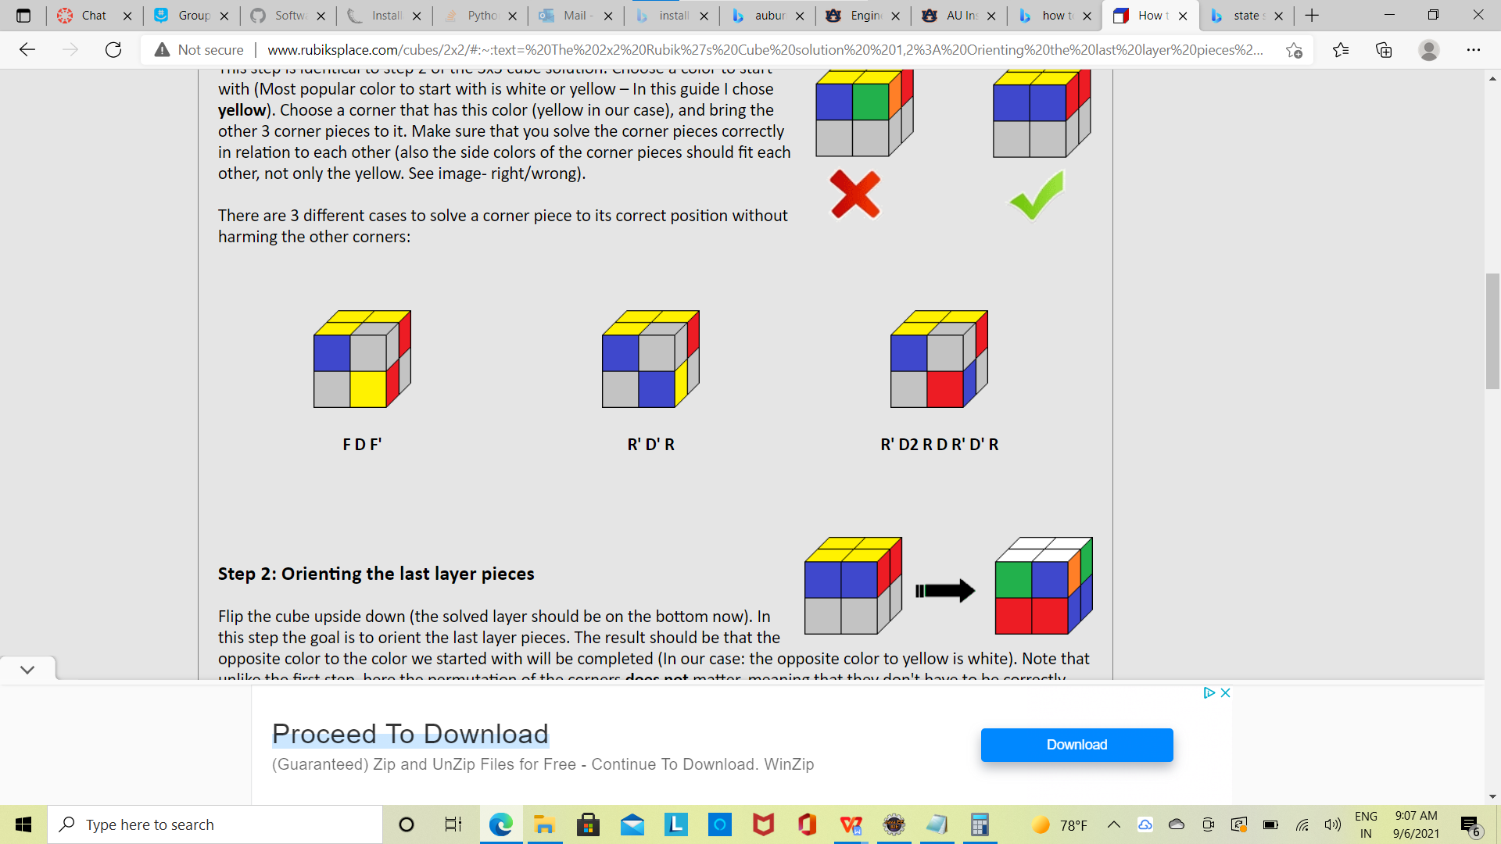

Since there are many possible combinations , the successor funtion depends on the current state of the rubics cube. For instance the successor function can be one of the formula shown in figure

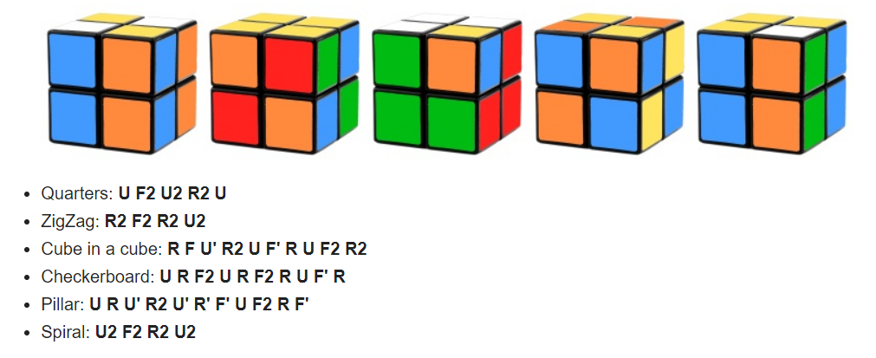

Depending on the current state formulas can be applied to obtain the next state , therefore a successor function for a rubics cube can be complex and it is the set of all the formulas stated in the picture above and based on the current state formula is choosed .The Initial state can be any of the unsolved state in a rubics cube and based on the state the successor function which is basically the formula shown above could be used to reach the next state and this process continues until we reach the goal state which is a solved rubics cube.